Q/Match the terms to their definitions.
1. Punctual a. always on time
2. Manager b. the person who gives you orders
3. Colleagues c. the people you work with
4. Customers d. the people who buy things from your company
5. Tasks e. pieces of work
6. Quality f. good or bad
7. Equipment g. phones and computers
8. Workspace h. desk, shelves, cupboards
9. Chronologically i. ordered by date
Q/ Complete the notes below with a verb in each space.
1. ………………….. to work every day.
2. ………………….. punctual.
3. ………………….. colleagues and customers.
4. ………………….. all tasks on time.
5. ………………….. all tasks well.
6. Not ………………….. computers for personal things.
7. ………………….. your workspace tidy.
8. ………………….. files sensibly.
Answers:
1. Go 2. Be 3. Respect 4. Do 5. Do 6. Use 7. Keep 8. Organize
Q/ Tick the correct column for each word according to the underlined sound.
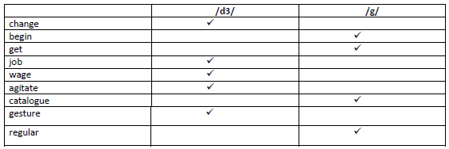
Q/ Complete the following blanks with the given words.
(interview, advert, get, working, smart, recruitment, like)
1. You look ……………
2. I’ve got an ………… for a summer job.
3. Could you put an …………… in the paper for a summer job?
4. I’m on my way to the …………. Agency.
5. Are you going to ……… a job in the university holidays?
6. Would you ………….. to work abroad?
7. Do you like …………. Alone or with other people?
Answers:
1. Smart 2. Interview 3. Advert 4. Recruitment 5. Get 6. Like 7. Working
Q/ Do as required.
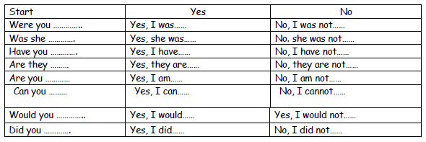
Q/ Complete the following blanks with the given words.
(employ, employment, employer, employee, employable)
1. A good ……… looks after all the people in the company.
2. The company has 200 ………. In its main office.
3. We would like to ………. You to work as a teacher.
4. What’s the length of ……………. In this job?
5. If you learn many skills in college, you will be ………… when you leave.
Answers:
1. Employer 2. Employee 3. Employ 4. Employment 5. Employable
Q/ What is the base word for each of the following nouns?
1. advisor …………………….
2. manager …………………….
3. deletion …………………….
4. efficiency …………………….
5. responsibility …………………….
6. payee …………………….
7. kindness …………………….
8. requirement …………………….
Answers:
1. Advice 2. Manage 3. Delete 4. Efficient 5. Responsible 6. Pay 7. Kind 8. Require

Q/ Match words to make a phrase.
1. freelance ………………… technology
2. mass ………………… studies
3. media ………………… overtime
4. company ………………… salary
5. starting …………1…… journalists
6. unpaid ………………… job
7. Information ………………… car
8. career – entry ………………… media
Answers:
1. Journalists 2. Media 3. Studies 4. Car 5. Salary 6. Overtime 7. Technology 8. Job
Q/ Read the text below. Box the nouns. Underline the verbs. Circle the adjectives.
The world of work is changing. At one time, most people got a job and they stayed in that job for
the whole of their life. Employers paid employees for their time. But in the modern world, you cannot
get expect to get a job for life when you finish your full-time education. You will probably have many
different jobs in your lifetime. Now, employers pay people for useful skills.
Answers:
Nouns: world, work, time, people, job, whole, life, employers, employees, time, world, job, life,
education, jobs, lifetime, employers, people, skills.
Verbs: is, changing, got, paid, cannot, expect, get, pay.
Adjectives: one, modern, full-time, different, useful.
Q/ Divide each sentence into parts / .
1. Employment is declining.
2. Unemployment is rising.
3. Many young people are out of work.
4. Good jobs are scarce.
5. Most employers want skilled workers.
6. Unskilled workers cannot get full-time positions
7. They work now and then.
8. They don’t earn every week.

Q/ Find the right match for each of these section headings on the left.

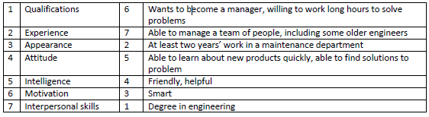

Q/ Complete each phrase with a suitable verb.
1. …………… a job description
2. ………….. an advertisement.
3. ……………. An application form
4. ……………. A short list
5. ……………… references
6. …………….. interviews
7. …………….. candidates
8. …………… the best candidate
Answers:
1. Write 2. Design 3. Complete/fill in 4. Make/produce 5. Take up/follow up
6. Conduct 7. Interview 8. Appoint
Q/ Write one or two letters in each space.
1. lan – ua – e
2. mana – er
3. en – oy
4. – ob
5. su - - est
6. – une
7. en – ineer
8. wa – e
9. collea – ue
10. a - - ressive
11. sub – ect
12. assi – nment
Answers:
1. language 2. Manager 3. Enjoy 4. Job 5. Suggest 6. June 7. Engineer 8. Wage
9. Colleague 10. Aggressive 11. Subject 12. Assignment
Q/ Change the following sentences into active or passive according to the tense of each sentence.
1. The manager writes a person description.
2. The manager designs a job advertisement.
3. The candidates complete the form.
4. She telephones the referees.
5. The advertisement is put in several newspapers
6. Candidates are sent an application form.

Answers:
1. A person description is written.
2. A job advertisement is designed.
3. The form is completed.
4. The referees are telephoned.
5. The manager puts the advertisement in several newspapers.
6. The manager sends candidates an application form.
Q/ Complete the following text with the given words.
( liquids, true, science, graph, prove, scientist, table, represent, collect, laboratory, materials, tests)
………………… is the study of how things work in the world. A …………….. usually works in a ……………… .
He /she works with many different kinds of ………….. , for example plastic or metal, and …………….. . A
scientist ……………. Things to …………….. a hypothesis. A hypothesis is an idea that something is …………. .
Scientists must …………. all the facts first. Then he/she often puts the fact in a ………….. with columns of
information, or in a …………. , with blocks or lines that …………….. the information.
Answers:
(science, scientists, laboratory, materials, liquids, tests, prove, true, collect, table, graph, represent)
Q/ Match the terms to their definitions.
1. proving a. a test, usually in a laboratory
2. method b. looking up information
3. hypothesis c. an idea of the truth
4. experiment d. information before it is organized
5. research e. a way of doing something
6. data f. what you learn from an experience
7. conclusions g. showing that something is always true

Q/ Put the words into the correct column.
That –the- they -both -then –there- with- hypothesis- thing -truth -think -this

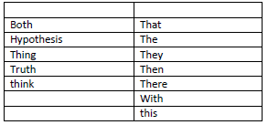

Q/ Complete the spaces with ( - ,a, an or the).
Firstly, ……….. scientist makes ……….. hypothesis, which means ……….. idea of the truth. Then he tests
……….. hypothesis. Scientists can test ……….. hypotheses in two main ways. They can do ………..
experiment, which means a test in a laboratory. Scientists study what happens during ………..
experiment. Or they can do ……….. Research, which means looking up ……….. Information. They usually
do research in ……….. Library or, nowadays, on ……….. internet.
Answers:
(a, a, an, the, a, an,an, _ , _ , a, the)
Q/ Complete the following spaces with given words.
(tides, noise, clouds, cycle)
1. What is the water …………….?
2. What’s that …………?
3. What are …………… made of?
4. Why do we have ……………. At the coast?
Answers:
1. Cycle 2. Noise 3. Clouds 4. Tides
Q/ Complete the text with This or These.
Look here. …………… is a picture of Isaac Newton in his laboratory. ………… shows his experiment with
light. …………… is a ray of light going into the prism here, and ……………. are the seven colours coming out
on …………. side. Light has other colours too, but …………. colours are the only ones that humans can see.
Answers:
(this, this, this, these, this, these)
P 123 see the book
Q/ Complete the following spaces by two or more that two letters.
The dist……………… of a place from the Equ……………… Is the ma……………… fac……………… that
infl……………… the ave……………… temp……………… of that place. The lat……………… of the loca………………
indicates its dist……………… from the Equ………………. other fact……………… include wind dir……………… and
hei……………… above sea lev………………
Answers:
(distance, equator, main, factor, influences, average, temperature, latitude, location, distance,
equator, factors, direction, height, level)
P 127 A see the book
Q/ Complete the words with two or more that two letters.
1. b………..d
2. b………..st
3. …………..th
4. f……………st
5. f………..ther
6. h…………d
7. res……………ch
8. s…………face
9. v…………..tical
10. w…………..ld
Answers:
1. bird 2. burst 3. earth 4. first 5. further 6. heard 7. research
8. surface 9. vertical 10. world
Q/ Change the following sentences into active or passive according to the tense of each sentence.
1. We needed four containers.
2. We chose a mineral bottle.
3. We did a simple experiment.
4. We needed containers.
5. We required a measuring device.
6. Glasses were chosen.
7. Rainfall was measured.
Answers:
1. Four containers were needed.
2. A mineral bottle was chosen.
3. A simple experiment was done.
4. Containers were needed.
5. A measuring device was required.
6. We chose glasses.
7. We measured rainfall.

Q/ Match each verb with a noun phrases.
1. Investigate ( ) the containers
2. Do ( 1 ) the relationship
3. Make ( ) the hypothesis
4. Fill ( ) an experiment
5. Mark ( ) the point
6. Prove ( ) a hole
Answers:
1. Investigate the relationship.
2. Do an experiment.
3. Make a hole.
4. Fill the containers.
5. Mark the point.
6. Prove the hypothesis.
QUESTION SAMPLES 1
Q1. A/ Match the terms to their definitions. (5 Marks)
………….. 1. hypothesis a. a way of doing something
………….. 2. method b. the people who buy things from your company
………….. 3. colleagues c. is the study of how things work in the world.
………….. 4. customers d. the people you work with
………….. 5. science e. is an idea that something is true
f. what you learn from an experience
Q1. B/ Complete the notes below with a verb in each space. (Only Five) (5 Marks)
1. ……………………. to work every day.
2. ……………………. punctual.
3. ……………………. colleagues and customers.
4. ……………………. all tasks on time.
5. ……………………. all tasks well.
6. not ……………………. Computers for personal things.
Q2. A/ Complete the following blanks with the given words. (6 Marks)
advert -get -working -employ -recruitment -employer
1. We would like to ………. You to work as a teacher.
2. Could you put an …………… in the paper for a summer job?
3. I’m on my way to the …………. Agency.
4. Are you going to ……… a job in the university holidays?
5. A good ……… looks after all the people in the company.
6. Do you like …………. Alone or with other people?
Q2. B/ Change the following sentences into active or passive according to the tense of each sentence.
(4 Marks)
1. Candidates are sent an application form.
2. The manager designs a job advertisement.
3. The candidates complete the form.
4. She telephones the referees.

Q3. A/ Find the right match for each of these section headings on the left. (6 Marks)

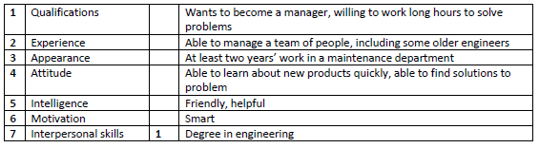
Q3. B/ Write one or two letters in each space. (Only Four) (4 Marks)
1. su … ….. est
2. lan …… ua ….. e
3. …… une
4. b………..d
5. f……………st
Q4. A/ Match each verb with a noun phrase. (5 Marks)
1. Investigate ( ) the containers
2. Do ( ) the relationship
3. Make ( 6 ) the hypothesis
4. Fill ( ) an experiment
5. Mark ( ) the point
6. Prove ( ) a hole
Q4. B/ Complete the text with This or These. (5 Marks)
Look here. This is a picture of Isaac Newton in his laboratory. ………… shows his experiment with light.
…………… is a ray of light going into the prism here and ……………. are the seven colours coming out on
…………. side. Light has other colours too, but …………. colours are the only ones that humans can see.

Q5. A/ Divide each sentence into parts / . (Only Five) (5 Marks)
1. Employment is declining.
2. Unemployment is rising.
3. Many young people are out of work.
4. Good jobs are scarce.
5. Most employers want skilled workers.
6. Unskilled workers cannot get full-time positions
Q6. A/ Read the text below. Underline the verbs. (5 Marks)
The world of work is changing. At one time, most people got a job and they stayed in that job for the
whole of their life. Employers paid employees for their time. But in the modern world, you cannot get
expect to get a job for life when you finish your full-time education. You will probably have many
different jobs in your lifetime. Now, employers pay people for useful skills.
Q6. B/ Circle the correct answer for each space. (Only Five) (5 Marks)
1. Scientists must …………. all the facts first.
a. prove b. collect c. tests d. experiment
2. …………………… is showing that something is always true.
a. proving b. idea c. graph d. conclusion
3. If you learn many skills in college, you will be ………… when you leave.
a. employable b. employment c. employee d. employ
4. Could you put an …………… in the paper for a summer job?
a. advertise b. advert c. advertisement d. adverted
5. The sound /d3/ can be found in:
a. login b. catalogue c. get d. gesture
6. the sound / ð/ can be found in:
a. both b. those c. them d. with
QUESTION SAMPLES 2
Q1/ Match the words to their definitions. (3 Points)
1. punctual a. the people who buy things from your company
2. manager b. pieces of work
3. colleagues c. always on time
4. customers d. good or bad
5. quality e. the people you work with
6. equipment f. the person who gives you orders
g. desk, shelves, cupboards
Q2/ What is the base word for each the following nouns. (6 Only) (3 Points)
1. advisor ………………………………..
2. manager ………………………………..
3. deletion ………………………………..
4. efficiency ………………………………..
5. responsibility ………………………………..
6. payee ………………………………..
7. kindness ………………………………..
8. requirement ………………………………..
Q3/ Tick the correct column for each word according to the underlined sound.
(3 Points)
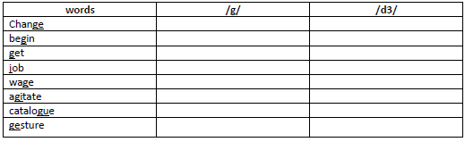
Q4/ Complete each word with the missing letter(s). (6 Only) (3 Points)
1. lan – ua – e 2. mana – er 3. en – oy 4. – ob 5. su – – est 6. – une
7. en – ineer 8. wa – e 9. collea – ue 10. a - - ressive 11. sub – ect 12. assi – nment
Q5/ Match the words to make phrases. (6 Only) (3 Points)
1. freelance ……… technology
2. mass ………. Studies
3. media ……… overtime
4. company ……… salary
5. starting ……… journalists
6. unpaid ……… job
7. information ………. car
8. career – entry ………. media
QUESTION SAMPLES 3
Q1/ Match the terms to their definitions. (6 Only) (3 Marks)
1. proving ( ) a. a test, usually in a laboratory
2. method ( ) b. looking up information
3. hypothesis ( ) c. an idea of the truth
4. experiment ( ) d. information before it is organized
5. research ( ) e. a way of doing something
6. data ( ) f. what you learn from an experience
7. conclusions ( ) g. showing that something is always true
Q2/ Change the following sentences into active or passive according to the tense of each sentence.
7. The manager writes a person description.
➢
8. The manager designs a job advertisement.
➢
9. Candidates are sent an application form.
➢
10. We required a measuring device.
➢
11. Glasses were chosen.
➢
12. Rainfall was measured.
➢
Q3/ Complete the following spaces by two or more that two letters. (3 Marks)
The dist……….….. of a place from the Equ……………. Is the ma…….fac……… that infl………… the
ave……….temp………… of that place. The lat…………. Of the loca…..……… ibdicates its dist………..
from the Equ…………… . Other fact………..….. include wind dir…….……… and hei…………….. above
sea lev…………..
Q4/ Complete the words with two or more than two letters. (6 Only) (3 Marks)
1. b………..d
2. b………..st
3. …………..th
4. f……………st
5. f………..ther
6. h…………d
7. res……………ch
Q5/ Complete the spaces with ( - ,a, an or the). (3 Marks)
Firstly, ……….. scientist makes ……….. hypothesis, which means ……….. idea of the truth. Then
he tests ……….. hypothesis. Scientists can test ……….. hypotheses in two main ways. They can do
……….. experiment, which means a test in a laboratory. Scientists study what happens during
……….. experiment. Or they can do ……….. Research, which means looking up ……….. Information.
They usually do research in ……….. Library or, nowadays, on ……….. internet.
Q6/ Complete the text with This or These. (3 Marks)
Look here. …………… is a picture of Isaac Newton in his laboratory. ………… shows his experiment with
light. …………… is a ray of light going into the prism here, and ……………. are the seven colours coming out
on …………. side. Light has other colours too, but …………. colours are the only ones that humans can see.

